|  |  |  |  |
| --- | --- | --- | --- |
| **Project** | **Release** | **Sprint** | **Feature** |
| int ProjectId;  List<Feature> Backlog;  List<Release> Releases; | List<Sprint> Sprints; | List<Feature> Features;  Datetime dueDate;  int amountOfCompletedWork;  int amountOfRemainingWork; | Developer Assignee;  int estimatedWork;  int remainingWork;  int completedWork; |

|  |  |  |
| --- | --- | --- |
| **User** | **Developer** | **ProjectManager** |
| int UserId;  String Name; |  |  |

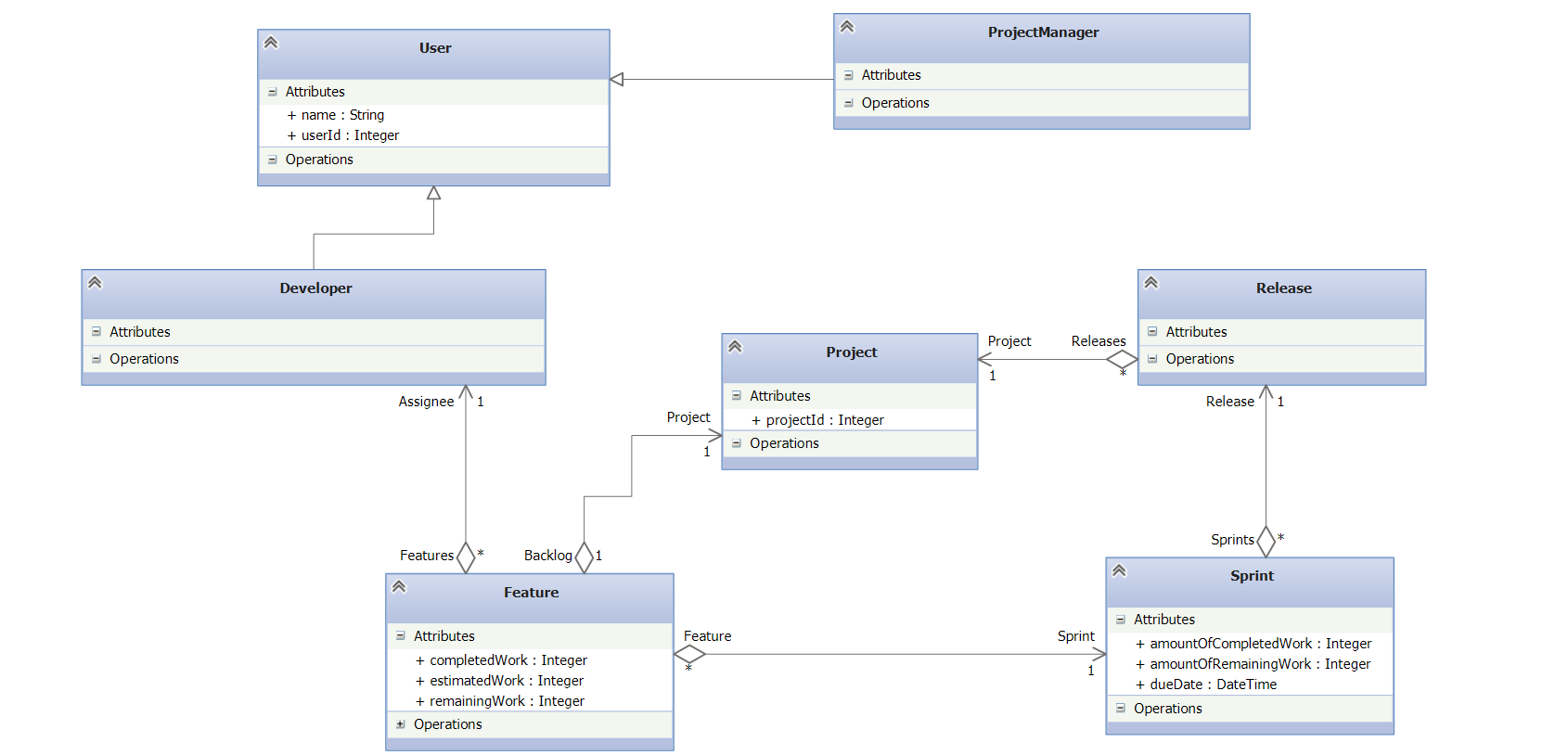

**import** java.util.Date;

**import** java.util.List;

**public class** User {

**int** userId;

String name;

}

**public class** Developer **extends** User {

}

**public class** ProjectManager **extends** User {

}

**public class** Project {

**int** projectId;

List<**Feature**> Backlog;

List<**Release**> Releases;

}

**public class** Release {

List<**Sprint**> Sprints;

}

**public class** Sprint {

List<**Feature**> Features;

Date dueDate;

**int** amountOfCompletedWork;

**int** amountOfRemainingWork;

}

**public class** Feature {

**Developer** Assignee;

**int** estimatedWork;

**int** remainingWork;

**int** completedWork;

}